YEAR 11 GENERAL HUMAN BIOLOGY

Weighting – 6% of year

Multiple Choice 10 Marks
Short Answer 25 Marks
Total 35 Marks
Task 9: DNA, Mitosis and Meiosis
Part 1: Multiple Choice (10 marks)

- Which of the following structures are made out of DNA?
- chromosomes
- chloroplasts
- cell membranes
- mitochondria

- How many different bases make up the “genetic alphabet” of DNA?
a) 2
b) 3
c) 4
d) 5

- What shape is a DNA molecule?
a) X shaped
b) Double helix, like a twisted ladder
c) Star shaped
d) Arch shaped, like a rainbow

- Which of the following statements is incorrect about chromosomes?
  - Chromosomes are made of DNA.
  - Chromosomes are found in the nucleus.
  - Chromosomes contain genes for inheritance.
  - Chromosomes are always visible under a microscope in stained cells.

- Which of the following statements is incorrect about mitosis?
  - It occurs in most body cells
  - It produces cells with the same number of chromosomes as the original cell.
  - It results in eggs or sperm.
  - It occurs in growing or repairing tissues.

- The diagrams below are microscopic photographs of a cell at various stages of mitosis.

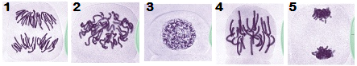

The correct sequence for these stages is
- 1,2,3,4,5
- 3,2,5,4,1
- 3,2,4,1,5
- 2,5,4,1,3

- The process that produces eggs (ova), sperm and pollen is called
  - mitosis.
  - meiosis.
  - cloning.
  - fertilisation.

8 A student was studying a living cell under a microscope and observed chromosomes becoming visible. As the student continued to watch, the original cell divided into two daughter cells. Which of the following would the student have observed if this cell was undergoing mitosis?

(a) Each chromosome became attached at the centromere to a spindle fibre.
(b) Each chromosome paired up with another of similar size.
(c) Sections of chromosome being exchanged between pairs.
(d) The daughter cells had half the number of chromosomes of the original cell.

9 During the process of mitosis and meiosis there are a number of clearly visible stages. During which stage of the cell cycle does replication of DNA occur?

- Prophase
- Meiosis
(c) Mitosis
(d) Interphase

10 . During cell division the DNA molecule replicates itself. The reason for this is so

- if the cell makes a mistake there is enough DNA to go around
- the daughter cells end up with the same genetic information as the parent cell
- the DNA can move out of the nucleus into the cytoplasm
- there are enough chromosomes for each cell produced.

Section B Short Answer 25 Marks
Question 1
How many chromosomes are present in a cell in a human ovary during each of the following stages

A________ Prophase of the first meiotic division

B________ At the end of telophase of the first division

C________ Prophase of the second meiotic division

D________ at the end of telophase of the second division
- marks)

Question 2
Describe and explain two differences between the processes of meiosis and mitosis.

1___________________________________________________________________________________________________________________________
____________________________________________________________________________________________________________________________
2_______________________________________________________________________________________________________________________________________________________________________________________________________________________________________________________ (4 marks)

Question 3
Complete the complementary DNA strand below. (1 mark)
A T T C G A A C
_____________________

Question 4
In the space below draw a diagram demonstrating the difference between a chromatid, chromosome and centromere. (3 marks)

Question 5. Explain the difference between a gene and an allele (2 marks)

__________________________________________________________________________________________________________________________________________________________________________________________________________________________________________________

Question 6.
The following are the steps in Meiosis. They are NOT in order. Label each correctly as either Metaphase, Prophase, Telophase or Anaphase followed by the number 1 or 2. (8 marks)

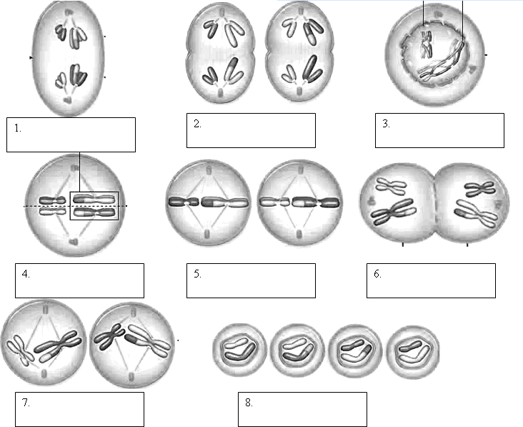

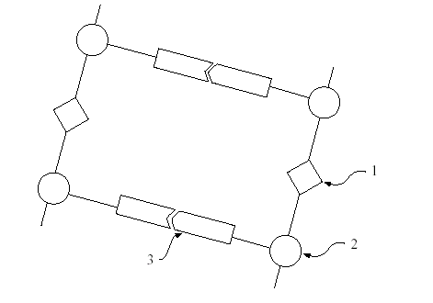
Question 7. Below is a diagram of DNA. Label 1, 2 and 3. (3 marks)
YEAR 11 GENERAL HUMAN BIOLOGY

GEHBY Task 9:
DNA, Mitosis and Meiosis
SCORES:
MC: /15

SA: /15

TOTAL: /30

_______ %

NAME:_____________________________

TEACHER:__________________________

DATE:______________________________

Section A: Multiple choice (15 Marks)
Answer all questions by circling the most correct answer on the multiple choice answer sheet.

1. a b c d
2. a b c d
3. a b c d
4. a b c d
5. a b c d
6. a b c d
7. a b c d
8. a b c d
9. a b c d
10. a b c d

